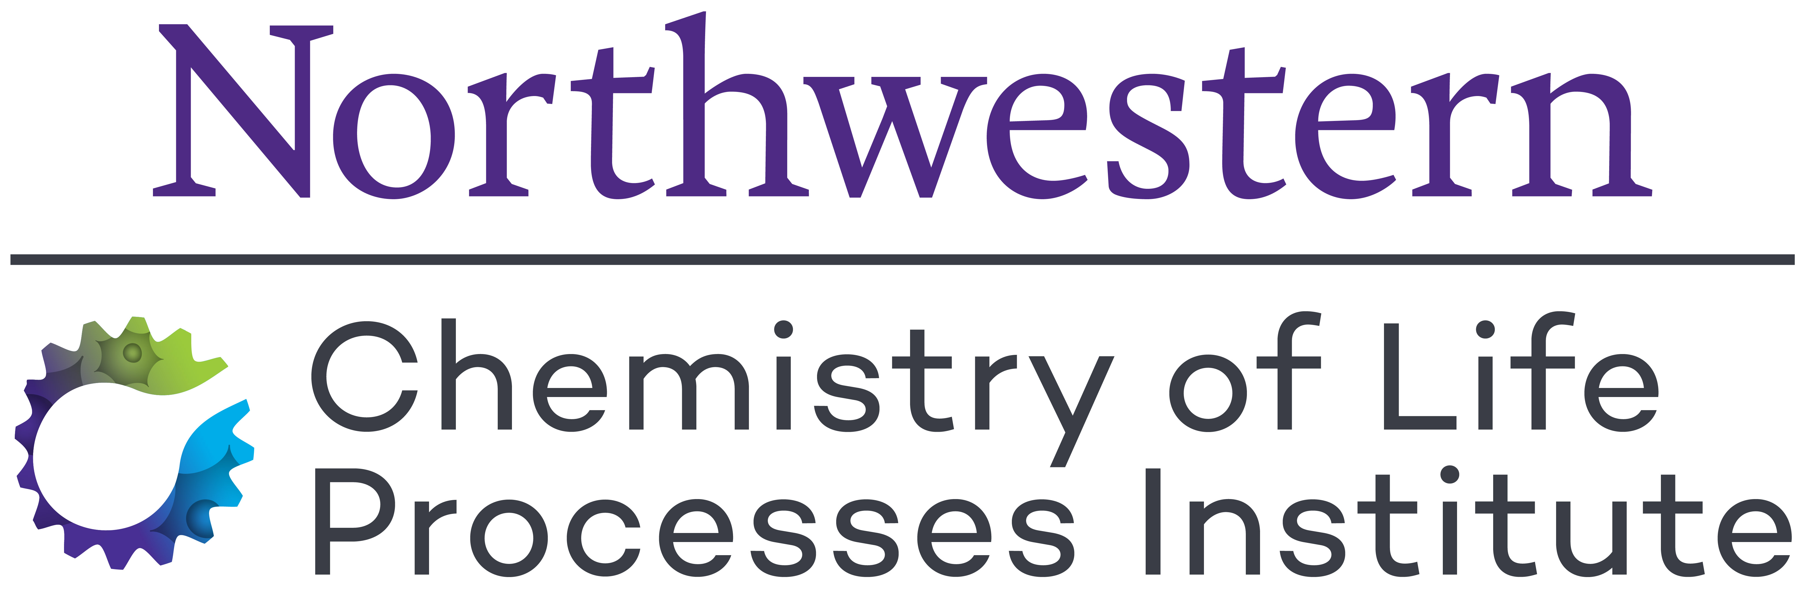
Handbook for Trainees and Mentors
2022-2023
CHEMISTRY OF LIFE PROCESSES
PREDOCTORAL TRAINING PROGRAM
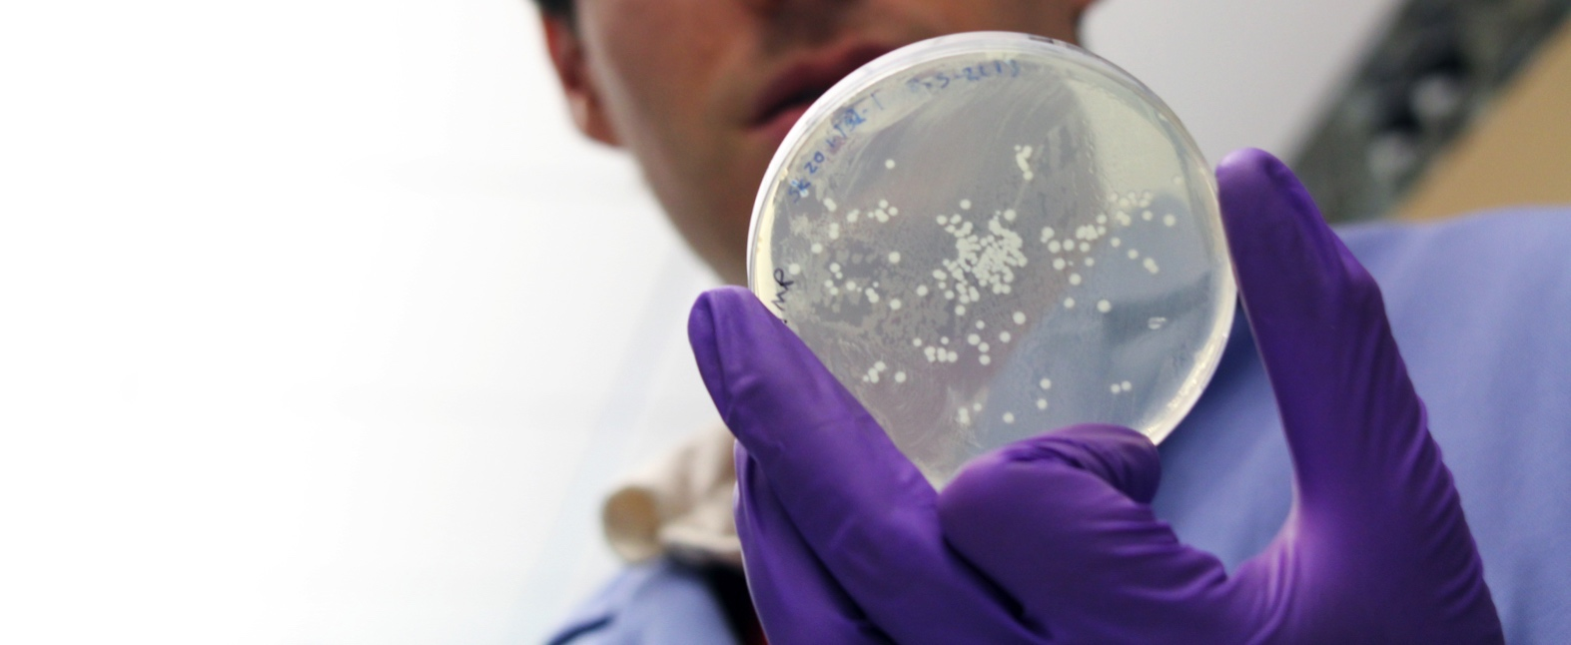
Dual Mentors
Each trainee selects two mentors, one with a background in chemistry and the other in the life sciences. The primary mentor fulfills the role of a graduate thesis advisor while also ensuring the trainee is fully participating in program activities and completing requirements. The secondary mentor operates in collaboration with the primary mentor, providing insights and strategies for problem-solving from a different perspective.
Immersive 10-Week Experience
Trainees spend 10 weeks total in the research group of their secondary mentor after their graduate program’s Qualifying Exams and before the end of their third year. This experience provides Trainees new analytical tools, model systems, and language for applying chemical approaches to research topics in the life sciences.
Seminar Series
Seminars feature topics that deepen Trainees’ understanding of research at the interface of chemistry and biology. Trainees select and invite external speakers from academia, and the pharmaceutical and biotech industries, to be sponsored by the CLP training program. Students meet with speakers at lunch and dinner to engage in more in-depth discussions of research approaches and methodologies.

Monthly Research Forum
Trainees present to their peers and program preceptors at the CLP Research Forum. Presentations not only enable trainees to gain experience in a public presentation of their work, but also provide a mechanism for gauging trainee progress and for identifying potential obstacles to the trainee’s project.
First-in-Class Laboratory Course
The course, CHEM/IBiS 416: Advanced Analytical Methods, covers topics such as high throughput testing, cheminformatics, chemical synthesis and purification, biologics production, in vitro testing, proteomics analysis, light microscopy and preclinical in vivo testing for efficacy and toxicity, plus in vitro and in vivo imaging techniques for targeting drug delivery, visualizing tumors, and documenting drug uptake and localization.
Entrepreneurship Training
Through meetings with entrepreneurs associated with the Chemistry of Life Processes Institute, trainees gain insight and training into translation of discoveries with implications for health and treatment of disease into the public realm.
Time with Program Directors
Trainees have the opportunity to meet with the program directors in a social setting to discuss project progress and career development.
Program Features

Trainees gain understanding and experience in transdisciplinary collaboration as an essential component in solving complex problems across the spectrum of health and disease.
Third Year:
- Complete CLP electives
- Continue dissertation research
- Present dissertation research at CLP Research Forums
- Attend a national research conference
- Continue meeting with mentors quarterly
- Participate in program activities
- 10-Week Immersive Experience (can be spread out)
- Complete Chem/IBiS 416 Practical Training in Chemical Biology Methods & Experimental Design

Subsequent Years:
- Continue dissertation research
- Engage in career development activities
- Develop grantsmanship
- Present research at national research meetings
- Continue regular meetings with mentors
- Participate in program activities
First Year:
- Work with Interim Advisor to identify training needs
- Complete at least (2) four-week intra- department (home department) rotations before choosing your thesis advisor
- Graduate program coursework
- Recommended completion of CHEM 415 Principles of Chemical Biology
- Select primary and secondary mentors, develop your research proposal
- Apply to program by July 1 (applications reviewed July – August)

Second Year:
- Appointment to CLP Training Grant (September 1 start date)
- Complete coursework
- Participate in program activities
- Present dissertation research at CLP Research Forums
- Meet with primary and secondary mentors at least quarterly
- Complete CHEM/IBiS 416 Practical Training in Chemical Biology Methods & Experimental Design

Eligibility

Eligibility for NIH training grant support will be determined by the following criteria:
- Candidates must meet NRSA qualifications as US citizens or permanent residents.
- Candidates must meet criteria of departmental programs plus provide tangible evidence of interest in transdisciplinary programs through undergraduate coursework, undergraduate research or internships.
- Candidates must have taken undergraduate courses in general chemistry and organic chemistry. Additional coursework in biology (organismal and cellular) and biochemistry is desirable, but not required.
Outstanding nominees who have not been appointed to the training grant due to lack of space or ineligibility for NRSA support will be considered for support through University fellowships.

CLP Program Timeline
Given the broad range of degree requirements and variance in the schedules of the graduate programs that enroll CLP trainees, we have been careful to construct the program’s training requirements in such a way as to enable you to stay in sync with your parent graduate program. The course requirements for the CLP Training Program have been designed with sufficient flexibility to enable you to use CLP-required courses to help fulfill the requirements of your degree-granting programs.
- CHEM 415 Principles of Chemical Biology
- CHEM/IBIS 416 Practical Methods in Chemical Biology and Experimental Design
- 1 Elective in complementary field from the list of approved electives
- RCR Training

Approved Electives

Coursework
Biology Courses |  | Chemistry Courses
Course # | Title | Course # | Title
DGP 401 | Biochemistry | Chem 401 | Principles of Inorganic Chemistry
DGP 405 | Cell Biology | Chem 408 | Design, Synthesis and Applications of Nanomaterials
DGP 410 | Molecular Biology & Genetics | Chem 410 | Physical Organic Chemistry
DGP 420 | Introduction to Pharmacology | Chem 411 | Organic Spectroscopy
DGP 422 | Introduction to Translational Research | Chem 413 | Organic Reactions
DGP 425 | Topics in Drug Discovery | Chem 415 | Bio-Organic Chemistry
DGP 435 | Receptors and Signaling Mechanisms | Chem 416 | Practical Methods in Chemical Biology and Experimental Design
DGP 440 | Immunology | Chem 432 | X-Ray Crystallography
DGP 442 | Microbiology | Chem 433 | Structural Inorganic Chemistry
DGP 450 | Tumor Cell Biology | Chem 434 | Inorganic Chemistry
DGP 462 | Eukaryotic Molecular Biology | Chem 445 | Advanced Physical Chemistry: Modern Spectroscopy
DGP 465 | Macromolecular Structure and Function | Chem 448 | Computational Chemistry
DGP 466 | Structural Basis of Signal Transduction | Chem 415 | Medicinal Chemistry: The Organic Chemistry of Drug Design and Action
DGP 475 | Virology | Chem 415 | Advanced Organic Chemistry
DGP 480 | Molecular Mechanisms of Carcinogenesis | Chem 419 | Advanced Organic Synthesis
DGP 484 | Statistics and Data Analysis for Life Scientists
DGP 485 | Data Science for Biomedical Researchers
DGP 486 | Advanced Bioinformatics (Genome Informatics)
IBIS 401 | Molecular Biophysics
IBIS 402 | Eukaryotic Molecular Biology
IBIS 407 | Genetics & Epigenetics
IBIS 409 | Biophysical Methods for Macromolecular Analysis
IBIS 410 | Quantitative Biology
IBIS 432 | Statistics for Life Sciences

Integration with Graduate Programs

Biomedical Engineering Graduate Program
Home Department Rotations: Complete (2) four-week rotations in the research groups of Biomedical Engineering faculty before selecting your thesis advisor. We recommend you rotate in the research groups of CLP Training Program preceptors.
Selection of Thesis Advisor and Program Mentors: Candidates for CLP traineeships are expected to choose a thesis advisor/ primary mentor from among the CLP biomedical engineering preceptors and a secondary mentor from among the CLP chemistry or chemical & biological engineering preceptors. The secondary mentor also sits on the graduate student’s thesis committee.

Chemistry Graduate Program
Home Department Rotations: Complete (2) four-week rotations in the labs of chemistry faculty before selecting your thesis advisor. We recommend you rotate in the research groups of CLP training program preceptors during first quarter.
Selection of Thesis Advisor: Candidates for CLP traineeships are expected to choose a thesis advisor/ primary mentor from among the program’s chemistry-affiliated preceptors and a secondary mentor from among the CLP life science preceptors. The secondary mentor also sits on the graduate student’s thesis committee.

Chemical & Biological Engineering Graduate Program
Home Department Rotations: The ChBE first year rotations count towards the home department rotations. We recommend you rotate in research groups of CLP training program preceptors.
Selection of Thesis Advisor: Candidates for CLP traineeships are expected to choose a thesis advisor/ primary mentor from among the program’s Chemical & Biological Engineering preceptors and a secondary mentor from among the CLP Life Sciences preceptors. The secondary mentor also sits on the graduate student’s thesis committee.

Driskill Graduate Program in the Life Sciences
Home Department Rotations: The DGP first year rotations count towards the home department rotations. We recommend you rotate in research groups of CLP Training Program preceptors.
Selection of Thesis Advisor and Program Mentors: Candidates for CLP traineeships are expected to choose a thesis advisor/ primary mentor from among the program’s life sciences-affiliated preceptors and a secondary mentor from among the CLP chemistry or chemical & biological engineering preceptors. The secondary mentor also sits on the graduate student’s thesis committee.

Interdepartmental Biological Sciences Graduate Program
Home Department Rotations: The IBiS first year rotations count towards the home department rotations. We recommend you rotate in research groups of CLP Training Program preceptors.
Selection of Thesis Advisor: Candidates for CLP traineeships are expected to choose a thesis advisor/ primary mentor from among the program’s life sciences-affiliated preceptors and a secondary mentor from among the CLP chemistry or chemical & biological engineering preceptors. The secondary mentor also sits on the graduate student’s thesis committee.

CLP Training Program Preceptors
Biomedical Engineering | Chemistry | Molecular Biosciences
Ameer, Guillermo | Gianneschi, Nathan | Bao, Xiaomin
Backman, Vadim | Hoffman, Brian | Carthew, Richard
Scott, Evan | Kalow, Julia | He, Yuan
Mrksich, Milan | Kelley, Shana | Horvath, Curt
Zhang, Hao | Malapit, Christian | Kelleher, Neil
 | Meade, Thomas | LaBonne, Carole
Chemical & Biological Engineering | Mirkin, Chad | Marko, John
Jewett, Michael | Odom, Teri | Mondragon, Alfonso
Leonard, Joshua | Schatz, George | Morimoto, Richard
Lucks, Julius | Scheidt, Karl | Pinkett, Heather
Tyo, Keith | Thomson, Regan | Radhakrishnan, Ishwar
Tullman Ercek, Danielle | Zhang, Xiaoyu | Rosenzweig, Amy
 |  | Wang, Xiaozhong (Alec)
Materials Science & Engineering | Medicine
Joester, Derk | Gottardi, Cara | Neurobiology
Olvera de la Cruz, Monica | Zhang, Bin | Allada, Ravi
Stupp, Samuel |  | Klein, William
 | Pharmacology | Kozorovitskiy, Yevgenia
Biochemistry & Molecular Genetics | Burridge, Paul
Ben-Sahra, Issam | George, Alfred
Foltz, Daniel | Horiuchi, Dai
Mendillo, Marc | Rocklin, Gabriel
Wang, Lu

The CLP Predoctoral Training Program has had unprecedented success in developing grantsmanship skills of its trainees. For instance, in 2015-16 three of the six graduate students who completed the program applied for and won highly competitive predoctoral fellowships. Former program members Amanda Bayer (left) and Jennifer Ferrer (right) were each awarded individual NIH/NIGMS predoctoral fellowships. In 2015 only 14.7% of fellowship applications were funded by NIGMS.

Now a Technical Lead of new pharmaceutical product development at Baxter International, Inc., Bayer was a graduate student in Thomas O’Halloran’s (Chemistry) lab where she used the tools and perspectives of inorganic chemistry to study the role of zinc in the fertilization process. She was jointly mentored by Teresa Woodruff (Obstetrics-Gynecology).

Currently a senior manager for alliance management at Tempus Labs, Ferrer worked on a new approach to drug delivery in the treatment of liver fibrosis under the supervision of Chad Mirkin (Chemistry) and Jason Wertheim (Transplant Surgery).

Application

The CLP Predoctoral Training Program supports up to 10 Trainees annually: 8 funded by NIGMS, 2 funded by university fellowships.

Applicants are asked to submit the following application materials on or before July 1 by 5:00pm:

- Completed CLP Training Program online application form.
- A one-page Training Statement describing career goals, commitment to, and a detailed plan for, completing the curricular requirements of the training program.
- A one-page research Project Description including background and biomedical significance of the research, a list of project goals and specific plans to achieve these objectives. The biological and chemical approaches to problem solving must be emphasized.
- Home Department Rotation Form.
- Copies of undergraduate and graduate transcripts. Official transcripts are not required.
- A short CV, including honors, presentations, research experience, publications, etc.
- Two signed letters of recommendation on letterhead:
a) One letter should be submitted by the applicant’s primary CLP preceptor/mentor. The letter must include a statement from the mentor reaffirming his/her/their commitment to the training program and agreeing to allow his/her/their mentee to satisfy all training program requirements.
b) The second letter should be obtained from the applicant’s secondary CLP preceptor/mentor who is familiar with the applicant’s academic accomplishments, research potential, and collaborative research project.

Further application instructions and forms can be found on the website: clp.northwestern.edu

Training Completion

Trainees will be required to provide documentation of their completion of all program requirements for final review by program leadership at the end of their second year of support. Trainees will retain a close affiliation with the program after the termination of their formal appointment. They will continue to be a vital component of the training program and are encouraged to continue participation in all program activities including seminars, Research Forums, and social activities throughout their graduate career. Trainees will continue to receive advice and support from their primary and secondary CLP mentors who will actively monitor the trainee’s progress towards his/her/their degree. Additional oversight will be provided by the trainee’s thesis committee, which includes the trainee’s secondary mentor.

Reappointment Evaluation

Second-year NIGMS-funded trainees’ progress is evaluated prior to reappointment to the training grant. Trainees and Primary/Secondary Mentors are required to submit materials to the CLP program coordinator for record-keeping and in support of the evaluation.
Trainees are asked to submit the following evaluation materials by July 1st:
- Completed CLP Training Program Renewal Form.
- Official Graduate School transcript showing completed coursework.
- One-page summary of trainee’s research accomplishments, techniques acquired and plans for the coming year.
- Copies and citations of all published papers, manuscripts submitted, meeting abstracts for talks and poster presentations, and awards received.
- Copy of Individual Development Plan updated from start of appointment.
- Letter from trainee’s primary mentor regarding progress in trainee’s research and academic standing.
- Letter from trainee’s secondary mentor describing trainee’s progress in applying transdisciplinary approaches to his/her research and the growth of the trainee’s capabilities in applying orthogonal approaches to research problems.

The CLP Evaluation Committee will consider all materials and make the decision to re-appoint based on the following criteria: first, that the trainee be in good standing with his/her/their graduate program; second, that the trainee has completed all CLP program requirements or has presented a feasible plan to do so; and third, that progress in research is clearly demonstrated.
Major changes in the trainee’s research project must be reviewed by the Evaluation Committee for applicability within the parameters of the program. Failure to meet program criteria will result in loss of training grant support.

- approaches to trainee’s research and the growth of trainee’s capabilities in applying orthogonal approaches to research problems.

The CLP Evaluation Committee will consider all of these materials and make the decision to reappoint based on the following criteria: first, that you be in good standing with trainee’s graduate program; second, that you will have completed all CLP program requirements or have presented a feasible plan to do so. Training Program Seminars, CLP Research Forums, research project must be reviewed by the Evaluation Committee for applicability within the parameters of the program. Failure to meet program criteria will result in loss of training grant support.

About the Chemistry of Life Processes Institute

Established by Northwestern University in 2004, the Chemistry of Life Processes Institute (CLP) fosters the transdisciplinary collaborations among physical and life scientists and clinicians that are required to address the complexity of the “big questions” underlying human health and disease. The Institute has created an ecosystem that enables basic and translational research and training that transcends disciplinary boundaries built upon a custom designed physical environment in the Richard and Barbara Silverman Hall for Molecular Therapeutics and Diagnostics.
The Institute’s 75 tenure-track faculty, while representing 20 departments spanning the schools of arts and sciences, engineering, and medicine, are renowned for team‐based, multi-disciplinary approaches to biomedical research. PhD-level technical staff maintain and develop cutting edge instrumentation and services, provides training, and collaborates with researchers to advance their research programs.

Program Leadership & Administration

Program Director
Neil L. Kelleher, PhD
Walter and Mary E. Glass Professor of Molecular Biosciences
Office: Silverman Hall 4-603
Email: n-kelleher@northwestern.edu
Ph: 847-467-4362
Assistant: Rex Yang
Email: kelleher-ofc@northwestern.edu

Associate Directors
Regan J. Thomson, PhD
Professor of Chemistry
Office: Tech K352
Email: r-thomson@northwestern.edu

Sheila M. Judge, PhD
Senior Director, Chemistry of Life Processes Institute
Office: Silverman Hall 3-603
Email: s-judge@northwestern.edu
Ph: 847-491-5868

Amy Rosenzweig, PhD
Weinberg Family Distinguished Professor of Life Sciences
Office: Cook 4137
amyr@northwestern.edu
Ph: 847-467-5301

Program Coordinator
Penelope Johnson
Office: Silverman Hall 3-633
Email: penelope.johnson@northwestern.edu
Ph: 847-467-7464

Website
www.clptrainingprogram.northwestern.edu

